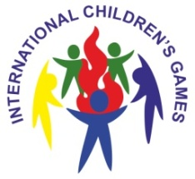
IX International Children's Sports Games
Russia, Chita

19-23 August 2019

Medallists
Медалисты
_____________________________________________________________________________________

Big race

Medal | Name
GOLD | MONGOLIAN
SILVER | CHINA
BRONZE | RUSSIA / REPUBLIC OF BURYATIA

